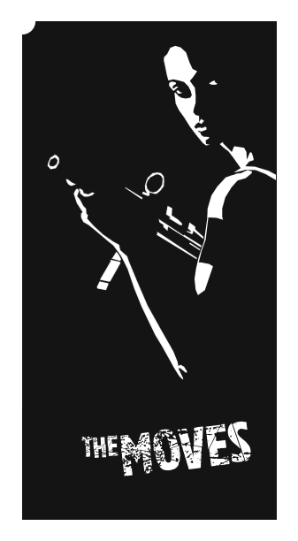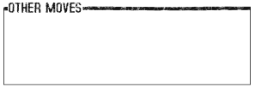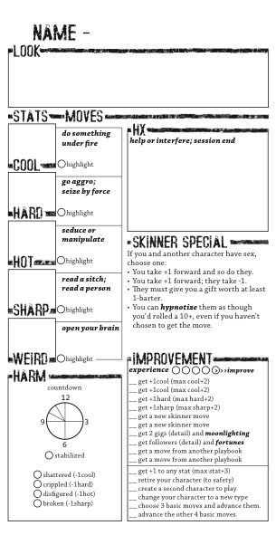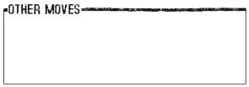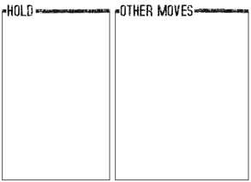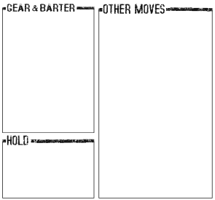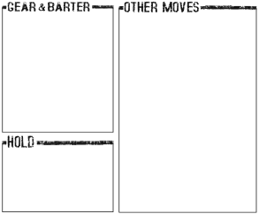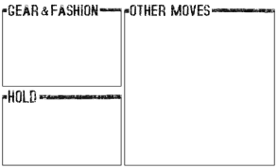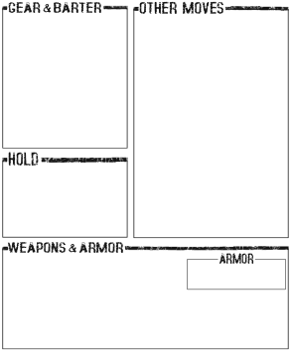

CAPITAL LTRS

CAPITAL LTRS

CAPITAL LTRS

CENTER FONT CAPITALS

Bookman old style font (unless Chaparrel Pro is owned). No indent, size 9 font, single spaced. Use 3pt paragraph spacing after header.

MOVES FORMAT

When you ***bold italics move condition***, roll+stat. On a 10+ condition, etc. On a 7-9 condition, etc. Miss condition left blank or specified.

If bullets are used:

* *Bullets pushed back in line with standard text*
* *font uses basic italics*
* *first letter usually not capitalized, with some exceptions*
* *blanks are typed as underscores rather than underline, as such ___.*

DOCUMENT FORMATTING

Recommendations for formatting of this document are as follows:

* *Text boxes are set to “in front of text” layout so as to avoid moving of other images/text boxes.*
* *For modification to black lines (as in the “capital LTRS header), select formatting of the image, de-select “lock aspect ratio” if needed, and modify size or width as preferred.*
* *Sections, titles, and etc are written in the font/format used (so, CAPITAL LTRS is written in crust_clean size 18 font, as that is the font used in that area. Likewise, these bullets are written in italics for the same reason.*

CENTER FONT CAPITALS

Bookman old style font (unless Chaparrel Pro is owned). No indent, size 9 font, single spaced. Use 3pt paragraph spacing after header.

MOVES FORMAT

When you ***bold italics move condition***, roll+stat. On a 10+ condition, etc. On a 7-9 condition, etc. Miss condition left blank or specified.

If bullets are used:

* *Bullets pushed back in line with standard text*
* *font uses basic italics*
* *first letter usually not capitalized, with some exceptions*
* *blanks are typed as underscores rather than underline, as such ___.*

SPLAT NAME

Introducing

Character introduction written here. Once the body text is finished, complete with the image below.

Body text written here. Font is bookman old style size 9, unless Chaparral Pro is owned. This section is usually reserved for a character’s stuff (their gang, establishment, holding, workspace, etc.

Body text written here. Font is bookman old style size 9, unless Chaparral Pro is owned. This section is usually reserved for a character’s stuff (their gang, establishment, holding, workspace, etc.

HEADER CPLTS

Body text written here. Font is bookman old style size 9, unless Chaparral Pro is owned. This section is usually reserved for additional rules that are pertinent to the character type

ADDITIONAL RULES

HEADER CPLT

○***Move name:*** When you [condition], roll/change/etc

○***Move name:*** When you [condition], roll/change/etc. If list is included, written as such:

*🞄 italics option a*

*🞄 italics option b*

*🞄 italics option c*

○***Move name:*** When you [condition], roll/change/etc

○***Move name:*** When you [condition], roll/change/etc

○***Move name:*** When you [condition], roll/change/etc

Other moves, gear, hold, and/or other boxes below. May also have a barter section if there is no room on the first page.

NAME

Name list, Upper cases, Etc.

More names, Sometimes oriented towards the opposite gender, Sometimes not.

STATS

Choose one set:

⦁ Cool+1 Hard+2 Hot+1 Sharp-0 Weird+3

⦁ Cool+1 Hard+2 Hot+1 Sharp=0 Weird+3

⦁ Cool+1 Hard+2 Hot+1 Sharp=0 Weird+3

⦁ Cool+1 Hard+2 Hot+1 Sharp=0 Weird+3

MOVES

You get all the basic moves. Choose __ Splat moves.

HX

Everyone introduces their character by name, look and outlook. Take your turn.

List the other characters’ names.

Go around again for Hx. On your turn, ____:



On the others’ turns:



At the end, find the character with the highest Hx on your sheet. Ask that player which of your stats in most interesting and highlight it. The MC will have you highlight a second stat too.

LOOK

Man, woman, ambiguous, transgressing, transgendered, or concealed.

Various look options

Various face options

Various eye options

Various body options

GEAR

You get:



IMPROVEMENT

Whenever you roll a highlighted stat, and whenever you reset your Hx with someone, mark an experience circle. When you mark the 5th, improve and erase.

Each time you improve, choose one of the options. Check it off; you can’t choose it again.

SPLAT MOVES

_ _ get +1stst (max stat+3)

_ _ get +1stst (max stat+3)

_ _ get +1stst (max stat+3)

_ _ get +1stst (max stat+3)

_ _ get a new splat move

_ _ get a new splat move

_ _ get 2 gigs (detail) and ***moonlighting***

_ _ get a gang (detail) and ***leadership***

_ _ get a move from another playbook

_ _ get a move from another playbook

CREATING A SPLAT

To create your splat, choose name, look, stats, moves, gear, and Hx

Splat sex move written here.

SPLAT SPECIAL

Lots of Boxes

For Playbooks